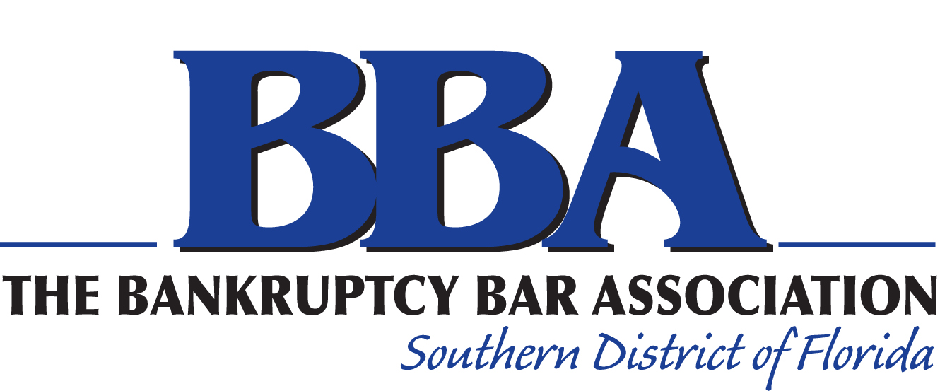

2023 Election Nominating Petition

I, the undersigned member in good standing of the Bankruptcy Bar Association of the Southern District of Florida (the “Association”), agree to be nominated for the following office:
□ President Elect □ Secretary □ At-Large Director
□ First Vice President □ Treasurer □ West Palm Beach Director
□ Second Vice President

I understand that to be eligible to stand for election I must timely obtain the signatures of at least five (5) members in good standing of the Association on this nominating petition, which signatures do not include my own. I further understand that if I do not timely obtain the signatures of at least five (5) members in good standing of the Association on this nominating petition I will not be eligible to run for the office to which I have agreed to be nominated.
Print Name of Nominee Signature of Nominee

_______________________________ _______________________________

We, the undersigned members in good standing of the Association, nominate the above-named nominee to stand for election for the above-named office.
Print Name Signature
1. _______________________________ _______________________________
2. _______________________________ _______________________________
3. _______________________________ _______________________________
4. _______________________________ _______________________________
5. _______________________________ _______________________________
6. _______________________________ _______________________________
7. _______________________________ _______________________________
8. _______________________________ _______________________________
9. _______________________________ _______________________________
10. ______________________________ _______________________________
Note: “Members in good standing” eligible to sign this nominating petition are those persons who have paid their annual Association dues and are otherwise qualified as members of the Association as of March 15, 2023.

Return nomination form by Wednesday, March 15, 2023 to Ross Hartog:

By mail: Markowitz, Ringel, Trusty & Hartog, P.A.
101 NE Third Avenue, Suite 1210
Miami, Florida 33301

By e-mail: rhartog@mrthlaw.com

